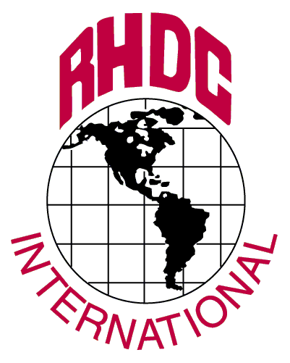
 | RHDC INTERNATIONAL
 | HOUSTON OFFICE:  8100 WASHINGTON AVE.  STE 105  HOUSTON, TX 77007  TEL: (713) 863-8080  FAX: (713) 869-0553 | CHICAGO OFFICE:  765 N. ROUTE 83, STE 108  BENSENVILLE, IL 60106  TEL: (6303) 595-7877  FAX: (630) 595-7811 | WASHINGTON DC. OFFICE:  801 N PITT ST SUITE 113.  ALEXANDRIA, VA 22314  PH : 202-232-7432  FAX: (703) 931-1057

You may not have realized that RHDC International has been providing Freight Forwarders & Exporters a full service Letter of Credit document preparation service since 1981. Since that time we have grown to become one of the largest in the country and our customer base includes the offices of major Freight Forwarders and Fortune 1000 companies across the U.S. and Canada.

We provide the following services:

- Review the L/C for terms and conditions, advising if changes are necessary
- Prepare all required documents; including the transport document (provide us your blank AWB’s or NVOCC BL’s). In the case of Carrier shipments we will make the BL Master for you.
- Arrange for legalization, if required, or Inspection certificates
- Coordinate with your staff or your forwarder for the transport document. Make any necessary adjustments with proper authorization. Adjustments must be made in writing via e-mail or fax
- Bank documents using our In-House Bank or the shipper’s bank
- Provide status information (when paid, etc.) on In-House Banking or Tracing Service documents via the internet or e-mail
- Provide copies for your records
- Furnish free pickup and delivery of documents in selected cities where RHDC has an office or courier arrangement.
- Documents can be e-mailed to LC@RHDC.com

“Freely Negotiable” L/C’s are banked using our In-House Banking Service (we have bank negotiators on premises), allowing us to provide status information and expedited processing on your files free of charge. Confirmed items will be sent to the appropriate bank in the U.S.

Standard turnaround is 72 Business hours from the time that we have all of the information to complete the file (i.e. all transport details). Each item submitted must be accompanied by our RHDC cover letter with your signature. Signing this cover letter is imperative for power of attorney purposes. We also handle AID L/C’s, call for pricing and details. Customers with higher volume business or multiple branch programs should contact us for our exclusive volume pricing programs. Contact us at 713-863-8080 or toll free at 800-468-3627 for our complete range of services and additional pricing information.

RHDC International

Setup and Pricing Sheet

Thank you for choosing RHDC International for your L/C needs. We want the L/C process to be a smooth one for
you, so we’ve enclosed the following information to help you. What is required to complete the transaction is the
following:

- An original or clean copy of the L/C. Try to get us the L/C as far ahead of shipment as possible because most of the documents we create take their data off the L/C. Having the L/C ahead of shipment allows us to track critical expiry, shipment and presentation timeframes so you don’t lose your claim under the L/C. In addition, we can review the L/C ahead of time and spot potential problems.

- Customer Invoice
- Transport information-either original B/L (ocean) or flight information for an air shipment. We will prepare either a house AWB or complete your own NVOCC B/L. Otherwise, we can use the carrier’s or your own prepared B/L or AWB
- Any third party survey or inspection reports (i.e., SGS). Generally, we would prefer to handle the SGS certificate. You provide a copy of the survey report and an invoice and we will contact SGS. The reason is that if the invoice is not per the L/C (and many we receive are not) then we may have to get the inspection certificate reissued or have to correct the one sent with the file. Having us handle the process saves you time and could save us (and your customer) time on the back end. The same goes for L/C’s requiring legalization; let us take the burden off of you by allowing us to handle any necessary legalization of the documents for you.
- Wire transfer information for the beneficiary. This is Very Important since all banks today refuse to issue checks to shippers. Beneficiary would also prefer to be paid faster via wire transfer

- A completed copy of the RHDC Company Cover Letter. This is also very important, as we need your signature on the form to authorize us to sign documents on your behalf, if necessary. If you do not sign the form we cannot complete the transaction. No exceptions on this point.



Our standard service provides for a 72 business hour turnaround from the time we receive the L/C along with all transportation details to complete the file. Although most customers do not require us to perform the following functions for their shipments, these additional fees would apply if needed:

We provide one copy of the completed file for your records. Lastly, we generally bank all non-restricted or “freely negotiable” L/C’s with our partner processing banks. We call this service, In-House Banking. In this case, we provide free status tracing (when documents have been checked, when they are paid, etc.) and provide you details via our unique web reporting system.

Please contact RHDC for information regarding our standard pricing information. Discount Pricing is available for
high volume business so save money by letting RHDC help with all of your Letter of Credit and Documentary
Collection business.

Our phone/fax/mailing address is:
RHDC International
8100 Washington Avenue, Suite 105
Houston, TX. 77007
Phone 713-863-8080
Fax 713-863-7487
Or
Toll free 1-800-HOT DOCS (1-800-468-3627)
www.rhdc.com
Please call us if you have any questions. We’re here to help.

